**Html:** it is a markup language used to give structure to the webpage

It is a front-end part of the web development

Documendation: mozilla, w3 school

**Visual studio:** contains emmet abbreviation .. helps to code faster

**Tags:** closing and self-closing

**Attributes**: not displayed… sets the value…

**Headings:** <h1> to <h6>

**Paragraph:** <p></p>

**Image**: <img src=>,,,

the url can also be added,

Tip: can use height and width,, however the actual size is being rendered.. so if the image is big the webpage takes time to load

**url adding:**

<a href =”can be internal, external as well as **id** with in the document”> can be text or image</a>

**Text editing:**

<sup> upper subscript

<sub> lower subscript

<strong> makes it bold

<em>italics

**Special character** : access with “&” eg: &copy;

**List:**

Can include anything links, images etc

Contains ordered, unordered, nested

**Forms:**

Input:

Grouping:

<div>,: used for block editing

<span>: used for inline editing; small chunk of HTMl

**CSS (cascading style sheet)**

**.css file**

**{property: value}**

**Used to style to the structure the webpage**

**Project 1:**

**Index1 and style 1**

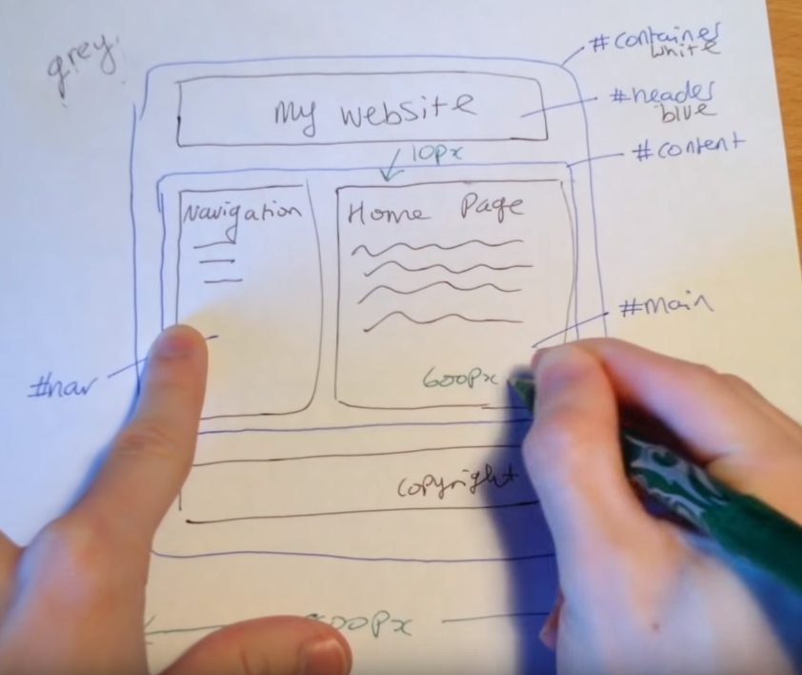

Overwriting power:

Inline…internal ……external

**Selectors:**

Tag; h1

Group: , eg h1,h2

Id: #idname

Class : (.) eg .classname

**Inheritance:**

The children inherits from the parent tag

**Last rule, specificity, universal selectors;**

Last rule: the last specified action in Css is executes

Universal selectors: called with * ,, this is the ;least powerful,, it selects and applies the changes to the whole document.. however, other actions will overwrite it.